PART A

1.

2.

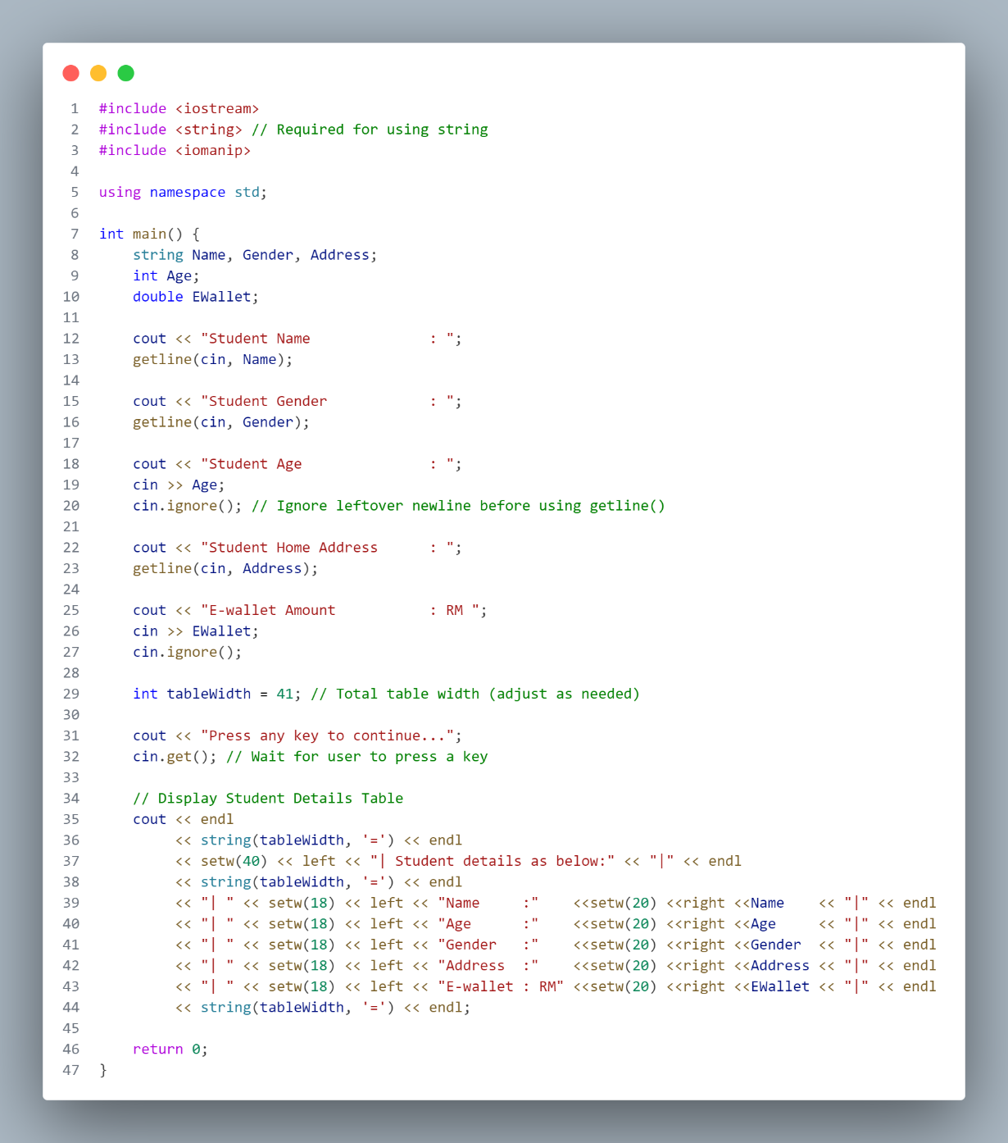

PART B

1.

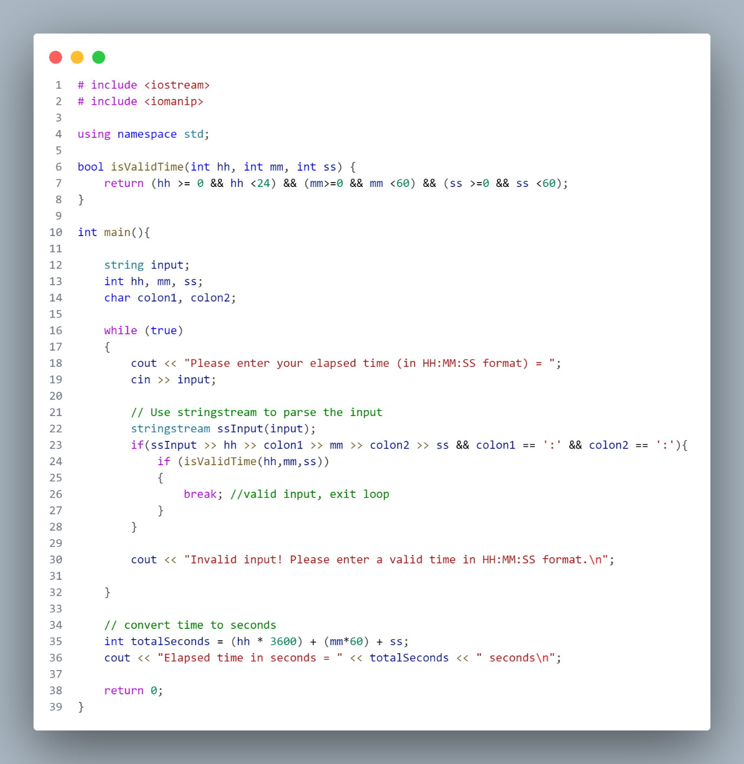

2.

PART C

1.

2.

3.

4.

5.

6.

7.

8.